**DLD LAB PROJECT**

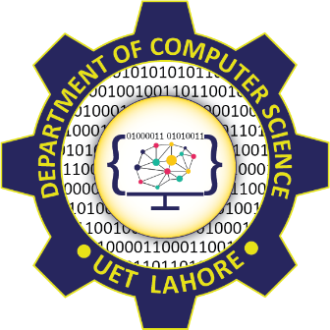

**Session 2023 - 2027**

**Submitted by:**

Sumaira Hafeez 2023-CS-1

Umar Saqi 2023-CS-2

Ayan Goreja 2023-CS-5

Mustafa 2023-CS-17

**Supervised by:**

Sir Tehseen

**Course:**

Digital Logic Design Lab

Department of Computer Science

**University of Engineering and Technology**

**Lahore Pakistan.**

**PROJECT 1**

1. **Transmitter and Receiver:**

The project involves designing a digital transmitter and receiver system that can send and receive data reliably over a communication channel. The system will be capable of encoding, transmitting, receiving, and decoding digital data using basic digital logic components.

* **Components and Features**

**1. Transmitter Module:**

* + **Encoder:** Convert digital input data into a suitable format for transmission. Common encoding schemes include Manchester encoding, NRZ (Non-Return to Zero), or variations of these.
  + **Modulator:** Modulate the encoded data onto a carrier signal. Options might include Amplitude Shift Keying (ASK), Frequency Shift Keying (FSK), or Phase Shift Keying (PSK).
  + **Driver Circuit:** Amplify and shape the modulated signal for transmission through a medium. This could involve buffer amplifiers and filtering to ensure signal integrity. **2. Receiver Module:**
  + **Receiver Circuit:** Capture and amplify the incoming signal from the medium.
  + **Demodulator:** Extract the digital data from the modulated carrier signal. This involves reversing the modulation process performed by the transmitter.
  + **Decoder:** Convert the received encoded data back into its original digital format.
  + **Error Detection and Correction:** Implement techniques such as parity checking or cyclic redundancy check (CRC) to detect and correct transmission errors.

**PROJECT 2**

1. **Traffic Lights:**

**Description:**

The Digital Traffic Lights Controller project is a digital circuit designed to simulate the operation of traffic lights at an intersection. It utilizes basic logic gates such as AND, OR, NOT gates, along with counters and state machines, to manage the timing and sequencing of traffic lights for multiple lanes. The project aims to demonstrate the application of digital logic principles in creating a functional traffic control system.

**Components:**

**1. Traffic Light Signals:** LEDs or other visual indicators represent the traffic lights for each lane, including:

* + Red light: Stop signal
  + Yellow light: Transition signal
  + Green light: Go signal

1. **Basic Logic Gates:** The core components of the traffic lights controller include basic logic gates such as:
   * AND gates: Combine control signals to determine when each traffic light should be active.
   * OR gates: Provide flexibility in defining traffic light sequences by combining control signals.
   * NOT gates: Invert control signals to enable logic negation.
2. **Counters and State Machines:** Sequential logic components such as counters or state machines are used to manage the timing and sequencing of traffic light phases.